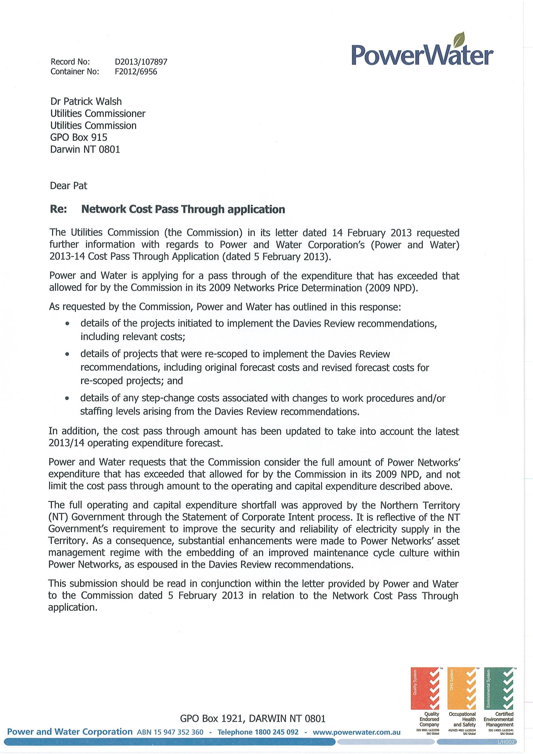

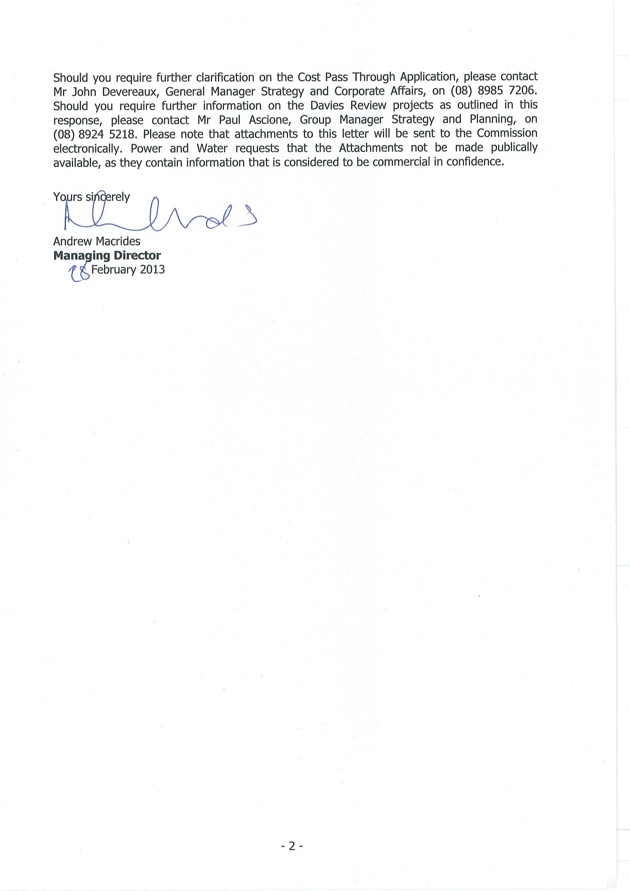

NETWORK COST PASS THROUGH APPLICATION

Response to the Commission’s Request for Further Information

For completeness, this document restates the pass through application submitted on 5 February 2013, with updated figures and the additional information requested by the Commission.

SUMMARY

In September and October 2008, a number of electrical equipment failures at Casuarina Zone Substation resulted in widespread power disruption to Darwin’s northern suburbs (the Casuarina incident). Consequently, the NT Government established an independent inquiry headed by Mervyn Davies (the Davies Review) to investigate these events and recommend improvements to be made to Power and Water’s operating and maintenance practices.

The root cause of the event was a catastrophic failure of an electrical circuit breaker in a uniquely harsh environment which contributes to the premature aging of electrical equipment. Power and Water’s subsequent implementation of the Davies Review recommendations was directed by Government and was driven by considerations of public and staff safety and the restoration of a reliable essential service to NT electricity consumers.

The broad ranging nature of the Davies Review resulted in recommendations which have had significant impacts on Power and Water’s operating and capital expenditures. The Davies Review of the Casuarina incident led to:
  - a thorough assessment of the condition of Power and Water’s network assets;

  - a significant program of inspection and remedial works, where asset condition was poor; and
  - the adoption of improved asset management processes1.

To address the immediate issues identified in the Davies Review recommendations, a dedicated business unit, the Remedial Asset Management Program (RAMP), was formed, and a Remedial Works Plan was developed. The objective of the Remedial Works Plan was to:
  - carry out the inspection and condition assessment of Power and Water’s network assets likely to be at risk;

  - develop a prioritised program of asset replacement and refurbishment, to minimise safety and supply security risks; and

  - develop a short term maintenance program that would evolve into a set of long term practices and consequently an improved maintenance culture.

A Long Term Action Plan was also developed, focusing on the maintenance practices to be adopted by Power Networks. This has resulted in a fundamental change to maintenance practices. Maintenance activity is more intensive and becoming more effective, as it transitions to a regime of asset inspection, condition monitoring and diagnostic testing.

Power and Water previously operated on constrained revenues resulting in asset management practices focused around corrective maintenance and run to failure. The Davies Review recommended a change to more preventative maintenance practices, which was implemented with Government support.

- Independent Enquiry into Casuarina Substation Events and Substation Maintenance across Darwin - Final Report Chairman: Mervyn Davies, 4 February 2009.

Power and Water requests that the Commission consider the full amount of Power Networks’ expenditure that has exceeded that allowed for by the Commission in its 2009 Network Price Determination (NPD), and not limit the cost pass through amount to projects and step changes to expenditure levels directly attributed to the Davies Review recommendations.

The full operating and capital expenditure shortfall was approved by the NT Government through the Statement of Corporate Intent (SCI) process. It is reflective of the Government’s requirement to improve the security and reliability of electricity supply in the Territory. As a consequence, substantial enhancements were made to Power Networks’ asset management regime with the embedding of an improved maintenance cycle culture within Power Networks, as espoused in the Davies Review recommendations.

OPERATING EXPENDITURE

The operating expenditure (opex) projects and step changes to operating expenditure levels directly attributed to the Davies Review recommendations are set out in Table A.

Table A – Operating Expenditure directly attributed to Davies Review recommendations ($M)

OPEX $M (actual/ forecast) | Davies Review recommendation |  | 2008/09 | 2009/10 | 2010/11 | 2011/12 | 2012/13 | 2013/14 | TOTAL
Remedial Works Program Opex | 11.11 Undertake an overall remedial program | RAMP2 | 15.30 | 5.00 | 8.56 | 5.68 | - | - | 34.54
Remedial Works Program Opex | 11.11 Undertake an overall remedial program | Substation Services Group3 | - | - | - | - | 10.11 | 5.00 | 15.11
Step change in Networks’ workforce levels | 11.8 Modernising maintenance knowledge |  | - | 1.39 | 1.43 | 4.09 | 4.22 | 4.34 | 15.47
Step change in Networks’ workforce levels | 11.9 Accelerate reform of maintenance operations
TOTAL $M |  |  | 15.30 | 6.39 | 9.99 | 9.77 | 14.33 | 9.34 | 65.11

RAMP Operating Costs

The short term recommendations from the Davies Review were largely managed by the Remedial Asset Maintenance Program (RAMP). RAMP was established as a separate Business Unit was by the Power and Water’s Managing Director, headed up by General Manager Keith Beven. At the peak of the program in 2011/12, the RAMP group had about 30 staff members.

The zone substation works carried out by the RAMP team were transferred to the Substation Services group of Power Networks in 2012/13. The condition assessment processes and thresholds developed to identify acceptable condition standards has become the responsibility of maintenance operations.

- The variance in RAMP opex can be explained as follows:
  - In 2008-09 there was a once-off expenditure of $10.7m on the hire of gensets to provide power while Casuarina Zone Substation was being restored.
  - In 2010-11, there was a significant increase in personnel.
- The 2013-14 Opex Forecast of $5m for the Substations Services group within Power Networks does not include internal expenses eg. corporate overheads and internal consumption, as internal expenses for the 2013-14 SCI forecast have not yet not been finalised (ie. allocated down to this level).

Step Change to Opex in Workforce Levels

2009-10 positions

The Davies Review identified an initial need to recruit six additional qualified electrical trades personnel, ideally experienced in condition monitoring techniques. It also recommended that a five year forecast of personnel requirements and their sourcing, to deliver the forecast works program, be reviewed annually.

The Davies Review also recommended that organisation changes resulting from a February 2008 report by Pricewaterhouse Coopers (PwC) into Power Networks’ Structure, Process and Capability be bedded down, to improve the responsibility and accountability for maintenance actions and job ownership by the workforce. In its February 2008 report, PwC recommended an additional nine positions covering planning, standards, customer connections, protections and field services, and recommended the adoption of the asset owner / service delivery model (refer to Attachment 1 “Structure, Process and Capability Review” by PricewaterhouseCoopers).

Following the internal review of workforce requirements per the recommendations of the Davies Review, an additional fifteen positions were approved and recruited to in 2009/10 (refer to Attachment 2 Power and Water Internal Office Memo, “Recruitment of New Positions within the Service Delivery Section (Power Networks) to Support the Restructure”).

2011-12 positions

Due to the increased capital works program resulting from the Davies Review recommendations for Power Networks, Power and Water engaged Huegin Consulting in 2010 to determine the size of the workforce required to deliver the program of works and identify whether a ‘gap’ exists versus the current workforce. To assess this, Huegin assessed the level and behaviour of demand for various capital projects and repairs and maintenance work, and compared this against the workforce profile at the time. Huegin developed a gap analysis model that mapped demand in hours and Full Time Equivalent (FTE) numbers for each personnel type against the supply (internal positions available) to calculate resource discrepancies (refer to Attachment 3 “Power and Water - Delivering the Program of Works – Sustainably” by Huegin Consulting).

Subsequent to the Huegin Report recommendations, a further 23 additional positions for Power Networks were approved and recruited to in early 2011 (refer to Attachment 4 for the approved Workforce Business Cases).4 A conservative approach was taken by Power Networks in 2010/11 not to request positions until the business was in a position to effectively use them, and as such not all of the positions recommended by Huegin Consulting were accepted.

- Of the 23 new positions, 16 related to the Strategy & Planning and Service Delivery groups of Power Networks, and 7 related to the RAMP/Substation Services group. As the personnel costs for RAMP/Substation Services are already included in the RAMP Operating Costs, these have been excluded from the calculation for the Step Changes to Opex. The cost of the additional positions in Strategy & Planning and Service Delivery groups of Power Networks have been included from 2011-12 onwards.

CAPITAL EXPENDITURE

Capital expenditure (capex) projects initiated or re-scoped to implement the Davies Review recommendations are set out in Table B.

Table B – Capital Expenditure directly attributed to the Davies Review recommendations5 ($M)

CAPEX $M (actual/ forecast) | Davies Review recommendation | 2008/09 | 2009/10 | 2010/11 | 2011/12 | 2012/13 | TOTAL
PXD39311  Restoration of Casuarina Zone Substation | 11.11 Replace Casuarina Zone Substation 11kV Switchboard | 3.07 | 4.67 | -0.97∗ | 1.03 | 0.00 | 7.79
PRD39541  Rebuild Snell St Zone Substation6 | 11.7 Report on asset condition, risks and failures  11.11 Undertake an overall remedial program | 0.00 | 1.31 | 5.55 | 14.18 | 12.50 | 33.55
PRD39501  Replace Manton 22kV Switchboard | 11.7 Report on asset condition, risks and failures  11.11 Undertake an overall remedial program | 0.00 | 0.00 | 0.39 | 1.21 | 2.00 | 3.59
PRD39712  Reinforce Winnellie – Berrimah 11kV Network | 11.7 Report on asset condition, risks and failures  11.11 Undertake an overall remedial program | 0.00 | 0.00 | 0.01 | 0.80 | 1.80 | 2.61
PRD39703  PRD39707  PXD39713  Purchase spare zone substation transformers | 11.7 Deliver improved systems and processes,  11.5 including supporting policies and policy  documentation | 0.00 | 0.77 | 2.18 | 0.67 | 0.19 | 3.81

- For further background information on individual business cases for the projects, refer to Attachment 5.
∗ The negative 2010/11 capex figure relating to the Restoration of Casuarina Zone Substation project was due to a journal adjustment.
- This project was included in the Power Networks Capital Expenditure Works Program prior to the Casuarina incident. Only the expenditure due to the expanded scope of the project has been included.

CAPEX $M (actual/ forecast) | Davies Review recommendation | 2008/09 | 2009/10 | 2010/11 | 2011/12 | 2012/13 | TOTAL
PRD39738  PRD39534  Purchase two mobile substations and switchboards | 11.7 Report on asset condition, risks and failures | 0.00 | 0.00 | 6.44 | 4.71 | 2.64 | 13.79
PRD30002  Rebuild Weddell  – Archer 66kV Line | 11.7 Report on asset condition, risks and failures | 0.00 | 0.00 | 0.00 | 1.93 | 12.00 | 13.93
PXK32080  Replace 22kV Katherine Switchboard | 11.7 Report on asset condition, risks and failures  11.11 Undertake an overall remedial program | 0.00 | 1.18 | 5.03 | 3.34 | 0.00 | 9.55
TOTAL $M |  | 3.07 | 7.93 | 18.62 | 27.87 | 31.13 | 88.61

With the exception of Rebuild Snell St Zone Substation (PRD39541), none of the capex projects outlined in Table B above were included in the Power Networks Capital Expenditure Works Program prior to the Casuarina incident (refer to the 2008/09 Statement of Corporate Intent (SCI) Power Networks Capital Expenditure Forecasts at Attachment 6).

The justification against the Davies Review recommendations for each of the capex projects in Table B is outlined below.

Restoration of Casuarina Zone Substation (PXD39311)

Project Description - Replace the 11kV switchboard

In September and October 2008 a number of switchboard failures resulted in widespread power disruption to Darwin’s northern suburbs. Mervyn Davies recommended the immediate replacement of this switchboard.7 Prior to the Davies Review this switchboard replacement was not included in the 2008/09 SCI.

Rebuild Snell St Zone Substation (PRD39541)

Project Description - Replace all assets at Snell St Zone Substation

Snell St Zone Substation assets, as part of the remedial program of works (as recommended by the Davies Review), were assessed as being in a very poor state and requiring immediate replacement.8 This project was included in 2008/09 SCI, but at $12.5 M. The option of replacing assets insitu was deemed unsafe for personnel, and the original scope expanded to include the use of adjacent land that was not large enough to accommodate a lower cost outdoor switchyard. Therefore more expensive indoor 66kV gas insulated switchgear was

- Davies, Independent Enquiry into Casuarina Substation Events and Substation Maintenance across Darwin, Final Report, 4 February 2009, pg. 14.
- Ibid., pg. 41. The Davies Review noted a prior recommendation of the Mehta Review was to replace oil filled switchgear and that Power and Water had included Snell Street, stating “The decision to widen the retrofit programme beyond the Mehta recommendations was an appropriately prudent step in minimising the oil hazard.”

required. Additionally, to mitigate against failure of the 11kV switchboard and zone substation transformers a temporary switchboard and transformer was installed. The actual capital expenditure of the project was $46.05 M, however only the additional amount of $33.5 M due to the expanded scope of the project has been included in Table B.

Replace Manton 22kV Switchboard (PRD39501)
Project Description - Replace the 22kV YSF6 Yorkshire switchboard at Manton Zone Substation An outcome of improved asset management practices and asset condition assessment (as
recommended by the Davies Review9) was gaining a better understanding of network assets.
This project was not on the 2008/09 SCI at the time due to limited understanding of the asset condition and failure modes. This type of switchgear was found to have partial discharge issues that resulted in a number of switchgear failures at Manton Zone Substation. The asset was deemed to be at the end of its serviceable life, with immediate replacement recommended.

Reinforce Winnellie – Berrimah 11kV Network (PRD39712)

Project Description - Install high capacity 11kV cables between Berrimah and Snell St Zone Substations

Snell St Zone Substation assets, as part of the remedial program of works, were assessed as being in a very poor state requiring immediate replacement. As it would take 3 to 4 years to construct a new zone substation, a number of projects were undertaken to mitigate against the loss of supply from this zone substation. This project provided backup supply capability from Berrimah Zone Substation to customers normally fed from Snell St Zone Substation to enable the works recommended by the Davies Review to be undertaken whilst preserving acceptable levels of security and reliability.

Purchase spare zone substation transformers (PRD39703, PRD39707, PXD39713)

Project Description - Purchase spare zone substation power transformers to mitigate against any failures.

Part of implementing better asset management practices (as recommended by the Davies Review) was to implement a spare parts policy that looked not only at parts required for maintenance but also essential spares to mitigate for equipment failure.10 Large power transformers are individually designed and constructed and the acquisition of a zone substation transformer normally takes a year or more. Power Networks had very few spare zone substation transformers and was therefore exposed to operating the network in an insecure condition for a long period of time in the event of the failure of certain transformers. Due to inadequate asset management practices at the time, these purchases had not been included in the 2008/09 SCI.

Purchase two mobile substations and switchboards (PRD39738, PRD39534)

Project Description - Purchase two Nomad mobile 66/22/11kV substations, and purchase two mobile 11/22kV switchboards.

- Ibid, pg. 58, 83, 84. The Davies Review recommended further investigation to remove the asset condition risk associated with Yorkshire switchgear. This was undertaken as part of the remedial program that was a major recommendation of the report.
- Ibid, pg. 56. The Davies Review noted and endorsed the finding of a previous review by Blanch, which was that Power and Water’s spare parts holdings were inadequate.

As part of the RAMP program of assessing asset condition11, a number of zone substations were identified where the assets had deteriorated to such an extent that a complete rebuild was necessary. As this replacement program would take 6 to 7 years, it was recommended that mobile substations and switchboards be procured to mitigate against catastrophic failure of zone substation transformers and switchgear. Again the lack of knowledge of asset condition prior to the Davies Review meant that no funding was included in the 2008/09 SCI.

Rebuild Weddell – Archer 66kV Line (PRD30002)

Project Description - Construct new 66kV Weddell to Archer transmission line

This line currently connects Weddell Power Station to the greater Darwin area. In accordance with the Davies recommendations, Power Networks instigated a condition assessment of all assets through the implementation of a robust preventative maintenance regime based on ‘objective need’ of the assets. Upon assessment, this line was found to be in a poor condition with severe cross-arm corrosion problems. Additionally a risk assessment recommended a complete rebuild, as the current line is designed to only survive a Category 1 cyclone event. The lack of knowledge of asset condition at the time coupled with inadequate risk management processes resulted in this project not being included in the 2008/09 SCI.

Replace 22kV Katherine Switchboard (PXK32080)

Project Description - Replace the 22kV YSF6 Yorkshire switchboard at Katherine

An outcome of improved asset management practices and asset condition assessment (as recommended by the Davies Review12) was gaining a better understanding of network assets. This project was not on the 2008/09 SCI at the time due to limited understanding of the asset condition and asset failure modes. This type of switchgear (same as Manton above) is now known to have partial discharge issues resulting in an unacceptable number of switchgear failures at Katherine. This switchboard was in such a poor state that a dehumidifier was installed to reduce the levels of surface partial discharge and safety restrictions instigated for personnel entering this switchroom.

CAPITAL AND OPERATING EXPENDITURE SHORTFALL

Power and Water requests that the Commission consider the full amount of Power Networks’ expenditure that has exceeded that allowed for by the Commission in its 2009 NPD, and not limit the cost pass through amount to the operating and capital expenditure described above.

The full operating and capital expenditure shortfall was approved by the NT Government through the Statement of Corporate Intent process. It is reflective of the Government’s requirement to improve the security and reliability of electricity supply in the Territory. As a consequence, substantial enhancements were made to Power Networks’ asset management regime with the embedding of an improved maintenance cycle culture within Power Networks, as espoused in the Davies Review recommendations. The increased costs associated with these changes are difficult to isolate and quantify. For example, increased costs associated with improving policy and procedure documentation, maintenance reporting and works program development.

- Ibid, pg. 84. The Davies Review recommended “a programme of rigorous condition assessment of all Zone Substation equipment immediately”.
- Ibid, pg. 58, 83, 84. The Davies report recommended further investigation to remove the asset condition risk associated with Yorkshire switchgear. This was undertaken as part of the remedial program that was a major recommendation of the report.

COST PASS THROUGH AMOUNT

Please note that this section has been updated since Power and Water’s 2013-14 Cost Pass Through Application dated 5 February 2013, to reflect updated 2008-09 capex and 2013-14 opex.

The required revenue increase as a result of the full capital and operating cost increases has been identified.

In the Commission’s 2009 NPD, the approach used was to determine the base year cost of service for 2009/10 and project a price path for the remaining years of the regulatory control period using a form of Total Factor Productivity (TFP) analysis. The Commission’s Final Determination was for a CPI-X form of price control with X made up as follows.

“4.89 GHD Meyrick concluded that, assuming that opex accounts for one third of electricity distribution costs while capital costs account for the remaining two thirds, it was reasonable to consider that available data produces an overall input price differential or X3 component estimate of 1.1%.

…

The Commission determines that the following component values are to be used for the purposes of calculating the value of the X factor to apply during the third regulatory period:

X1 = 0.0%;

X2 = 0.25%; and

X3 = 1.1% where:

and

X1 = the difference between the TFP growth for the electricity distribution industry in Australia and that for the economy as a whole;

X2 = the difference between the best observed operating expenditure partial productivity level in the electricity distribution industry in Australia and Power and Water’s operating expenditure partial productivity level; and

X3 = the difference between the input price growth for Power and Water and that for the economy as whole;

X = X1 + X2 – X3 ” 13

Allowing for the rounding of X factors in the Final Determination, the components of X3 were thus as follows:

X3 = X3Opex – X3Capex
where:
X3Opex = 1/3 X 0.9% = 0.3% X3Capex = 2/3 X 1.2% = 0.8% 14

- Utilities Commission, Final Determination Networks Pricing: 2009 Regulatory Reset, March 2009, pp. 39, 43- 44.
- Utilities Commission, Price Control Mechanism, Final Decision Paper: 2009 Regulatory Reset, May 2008,
p. 73.

The base year levels of capex and opex of the Commission’s decision were as follows: Opex: $45.580 M 15
Capex: $56.782 M 16

The levels of capex and opex that formed the basis for the Commission’s decision for the third regulatory control period are recreated in the following calculation. The assumed volume growth underpinning the decision is the assumed annual quantity growth used in Commission’s modelling for the 2009 NPD, g = 2.5%17. The decision has been adjusted for out-turn CPI. The imputed capex and opex allowances are set out in Table 1. Also shown is the actual and forecast revenue through prices.

Table 1 – Opex and capex allowances from the Commission’s 2009 NPD ($M)

Year | 2008/09 | 2009/10 | 2010/11 | 2011/12 | 2012/13 | 2013/14 | 2009-14
CPI18 | 2.33% | 4.25% | 1.82% | 2.85% | 3.39% | 1.76% | -
Opex allowance19 | 45.6 | 48.7 | 50.9 | 53.7 | 56.9 | 59.4 | 315.1
Capex allowance20 | 56.8 | 61.2 | 64.3 | 68.4 | 73.0 | 76.8 | 400.5
Total allowance | 102.4 | 109.9 | 115.2 | 122.0 | 129.9 | 136.2 | 715.6
Actual/forecast  revenue | 83.8 | 102.6 | 100.6 | 104.7 | 115.6 | 123.8 | 631.1

The extent to which the capex and opex incurred by Power and Water has, and is expected to, exceed regulatory allowances is shown in Table 2 and 3, and summarised in Table 4 and Figure 1.

Table 2 – Actual and forecast opex compared with the regulatory allowance ($M)

Year | 2008/09 | 2009/10 | 2010/11 | 2011/12 | 2012/13 | 2013/14 | Total
Opex actual/forecast | 84.3 | 78.5 | 93.0 | 101.1 | 97.8 | 93.9 | 548.6
Opex allowance | 45.6 | 48.7 | 50.9 | 53.7 | 56.9 | 59.4 | 315.1
Incremental Opex | 38.7 | 29.8 | 42.1 | 47.5 | 40.9 | 34.5 | 233.4

Table 3 – Actual and forecast capex compared with the regulatory allowance ($M)

Year | 2008/09 | 2009/10 | 2010/11 | 2011/12 | 2012/13 | 2013/14 | Total
Capex actual/forecast | 65.9 | 85.2 | 88.8 | 78.8 | 123.8 | 98.7 | 541.2
Capex allowance | 56.8 | 61.2 | 64.3 | 68.4 | 73.0 | 76.8 | 400.5
Incremental Capex | 9.1 | 24.0 | 24.5 | 10.4 | 50.7 | 21.9 | 140.7

Table 4 – Total increment ($M)

Year | 2008/09 | 2009/10 | 2010/11 | 2011/12 | 2012/13 | 2013/14 | Total
Opex actual/forecast | 84.3 | 78.5 | 93.0 | 101.1 | 97.8 | 93.9 | 548.6
Capex actual/forecast | 65.9 | 85.2 | 88.8 | 78.8 | 123.8 | 98.7 | 541.2
Incremental opex | 38.7 | 29.8 | 42.1 | 47.5 | 40.9 | 34.5 | 233.4
Incremental capex | 9.1 | 24.0 | 24.5 | 10.4 | 50.7 | 21.9 | 140.7
Total increment | 47.8 | 53.8 | 66.6 | 57.9 | 91.6 | 56.4 | 374.1

- Utilities Commission, Final Determination Networks Pricing: 2009 Regulatory Reset, March 2009, p.79.
- Ibid. p. 63.
- Ibid. Table 3-2, p. 23.
- Assumed CPI is taken as the CPI approved for each annual Network Tariff submission.
- Opex escalation is calculated as: (1 + X3Opex) * (1 - X2) * (1 + CPI) * (1 + g).
- Capex escalation is calculated as: (1 + X3Capex) * (1 + CPI) * (1 + g).

Figure 1 – Actual and forecast opex, capex and revenue compared with the regulatory allowance ($M)
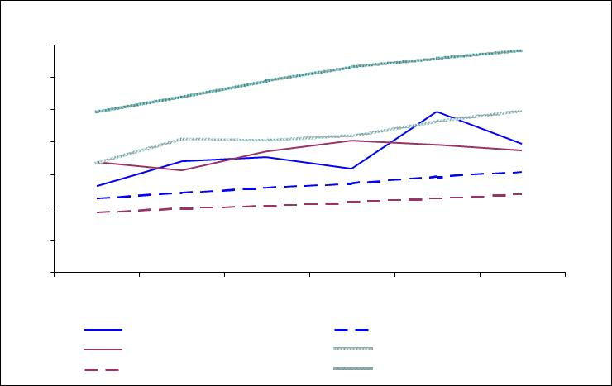

175

150

125

100
$ million

75

50

25

0
2008-09 2009-10 2010-11 2011-12 2012-13
Forecast

2013-14
Forecast

PWC Actual Capex 2009 NPD UC capex allow ance PWC Actual Opex PWC Actual Revenue
2009 NPD UC Opex allow ance PWC Required Revenue

The total impact on Power and Water of this over expenditure during the third regulatory control period is calculated as at 2013/14, as follows:
  - Incremental capital expenditure on system assets (with a life of 50 years) is rolled forward to determine the annual cost of supporting it. This also determines the increment in the asset value that would be carried forward to the fourth regulatory control period; and
  - Incremental capex and opex amounts are escalated to 2013/14 using the pre-tax real WACC of 6.82% determined by the Commission21.
The capital expenditure roll forward calculation is shown in Table 5.

Table 5 – Incremental capital expenditure roll forward ($M)

Year | 2008/09 | 2009/10 | 2010/11 | 2011/12 | 2012/13 | 2013/14 | 2014/15
Incremental RAB calculation
Opening asset base | 0.0 | 9.1 | 33.3 | 57.8 | 68.7 | 120.4 | 142.0
Capex | 9.1 | 24.0 | 24.5 | 10.4 | 50.7 | 21.9
Depreciation | 0.0 | -0.2 | -0.7 | -1.2 | -1.4 | -2.4
Indexation | 0.0 | 0.4 | 0.6 | 1.6 | 2.3 | 2.1
Closing asset base | 9.1 | 33.3 | 57.8 | 68.7 | 120.4 | 142.0
Incremental expenditure on capex calculation
Return on assets | 0.3 | 1.4 | 3.1 | 4.3 | 6.4 | 8.9
Depreciation (Return of) | 0.0 | 0.2 | 0.7 | 1.2 | 1.4 | 2.4
Incremental capex (return on and of) | 0.3 | 1.6 | 3.8 | 5.5 | 7.8 | 11.4

- Utilities Commission, Final Determination Networks Pricing: 2009 Regulatory Reset, March 2009, p. 36.

The incremental operating expenditures and incremental return on and return of capital expenditure are therefore as shown in Table 6.

Table 6 – Incremental expenditure ($M)

Year | 2008/09 | 2009/10 | 2010/11 | 2011/12 | 2012/13 | 2013/14 | Total
Incremental opex | 38.7 | 29.8 | 42.1 | 47.5 | 40.9 | 34.5 | 233.4
Incremental capex (return on and of) | 0.3 | 1.6 | 3.8 | 5.5 | 7.8 | 11.4 | 30.4
Total | 39.0 | 31.4 | 45.9 | 52.9 | 48.7 | 45.8 | 263.8

RECOVERY OF THE COST PASS THROUGH

There is one remaining year of the existing regulatory control period in which the proposed pass through amount could be recovered, 2013/14. Depending on the Commission’s Final Decision, it may not be possible to recover the whole amount of the pass through in a single year, without an unacceptably large increase in network prices.

Power and Water therefore proposes a three-stage approach to recovering the pass through amount associated with the implementation of the Davies Review recommendations:

- The additional revenue to be recovered in 2013/14 would be set at $45.8 M. This represents an increase in the weighted average network price of approximately 37%, and would align the price in the final year of the third regulatory control period with the revenue required to cover additional capital and operating costs.

- The revenue shortfall in the prior years to 2013/14 would be indexed and carried forward to the fourth regulatory control period. This is calculated in Table 7.

Table 7 – Recovery of over expenditure prior to 2013/14 ($M)

Year | 2008/09 | 2009/10 | 2010/11 | 2011/12 | 2012/13 | 2014/15
Incremental expenditure | 39.0 | 31.4 | 45.9 | 52.9 | 48.7
Indexation to 2014/15 | 1.4856 | 1.3908 | 1.3020 | 1.2189 | 1.1411
Indexed to 2014/15 | 57.9 | 43.7 | 59.7 | 64.5 | 55.6 | 281.5

Power and Water proposes that the amount of $281.5 M be recovered in the fourth regulatory control period. If recovered as equal instalments, this would represent a network price increase of approximately 33% in 2014/15.

The most convenient way of permitting this sum to be recovered, whilst allowing for some flexibility in the annual recovery, would be to use the overs and unders provision that will be established by the Commission as part of the revenue cap form of price control in 2014/15.

- The Regulatory Asset Base (RAB) would be increased by the rolled forward value of capital over expenditure, of $142 M, at the commencement of the fourth regulatory control period.

In this way, Power and Water would eventually recover the additional costs arising from the implementation of the Davies Review recommendations as permitted by the Commission’s 2009 Networks Price Determination.

Alternate Approach

If the Commission only accepts the operating and capital expenditure projects and step changes that can be directly attributed to the implementation of the Davies Review recommendations, then Power and Water requests a full cost pass through in 2013-14 of the total amount, $104.5 M, as detailed in Table 8 below.

Table 8 – Recovery of Expenditure attributed to Davies ($M)

Year | 2008/09 | 2009/10 | 2010/11 | 2011/12 | 2012/13 | 2013/14 | TOTAL
Incremental opex | 15.3 | 6.4 | 10.0 | 9.8 | 14.3 | 9.3 | 65.1
Incremental capex (return on and of) | 0.1 | 0.5 | 1.6 | 3.6 | 6.2 | 7.9 | 19.9
Indexation to 2013/14 | 1.4856 | 1.3908 | 1.3020 | 1.2189 | 1.1411 | 0.0
Indexed to 2013/14 | 22.9 | 9.6 | 15.1 | 16.3 | 23.4 | 17.2 | 104.55

If this is the Commission’s preferred approach, Power and Water requests that a reconciliation of the actual expenditure incurred by Power Networks during the third regulatory control period is undertaken as part of the 2014 Network Price Determination process, as it impacts significantly on Power Networks on-going commercial viability.

